**Riphah International University**



**Alisha Ishrat**

**40851**

**CS-6**

**Lab#4**

**08/09/2024**

**Task 1:**

Creating the file with file name **LINUXOS.**

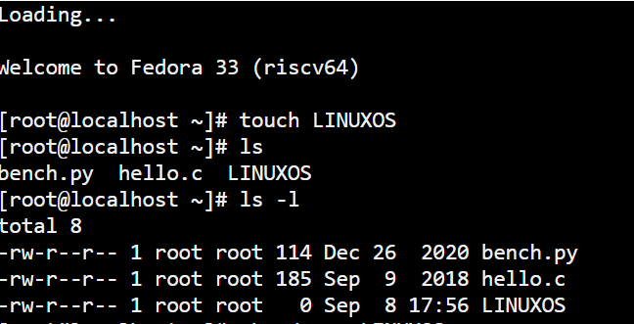

Giving full permission to user(owner).

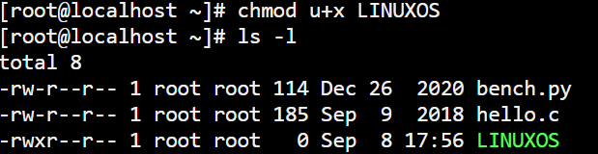

Giving read and write permission to Group.

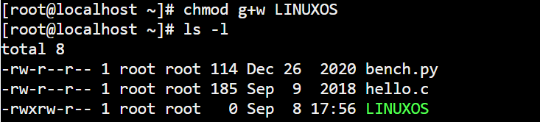

Giving only read permission to Others.

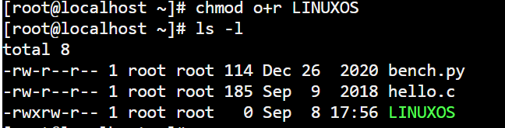

**By 2nd Method:**

Creating the file with file name **LINUXOS.**

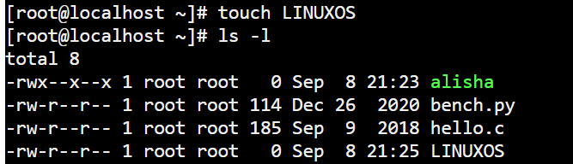

Giving full permission to user(owner), read and write permission to Group and only read permission to Others.

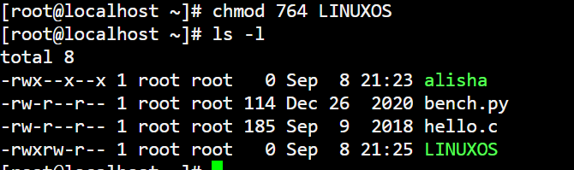

**Task 2:**

Creating directory **lab4**.

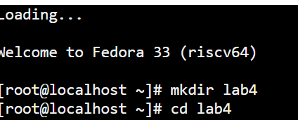

Creating files inside of **lab4** directory **quiz**, **report** and **cprogram**.

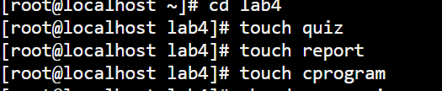

Giving permissions to quiz file.

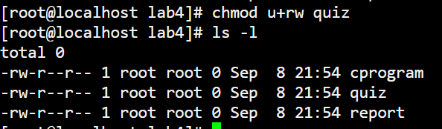

Giving permissions to report file.

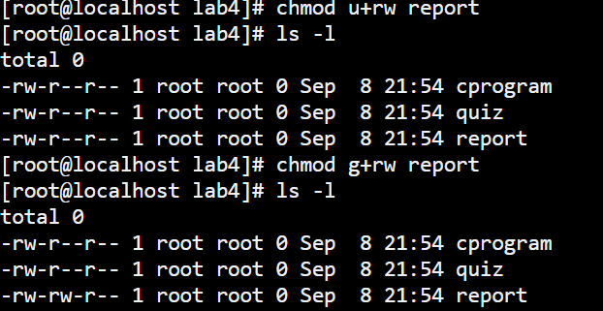

Giving permissions to cprogram file.

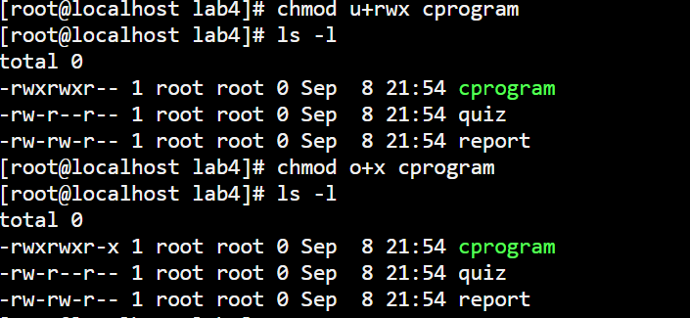

**Task 3:**

Creation of two directories **OSLab** and **OSTheory**.

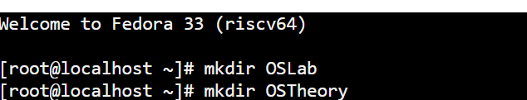

In **OSLab** directory create three files **Overview**, **Details** and **Applications**.

* Creation of **Overview** File.

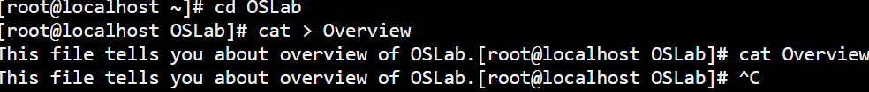

* Creation of **Details** File.

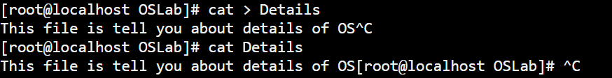

* Creation of **Applications** File.





Now, concatenating **Overview**, **Details** and **Applications** files into new file name **Combinedtext**.

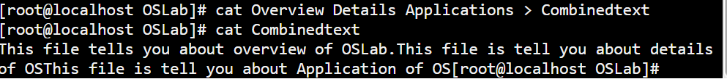

**Task 4:**

Creation of **Directory A** named as **DA** with two files **FinalTerm** and **MidTerm**.

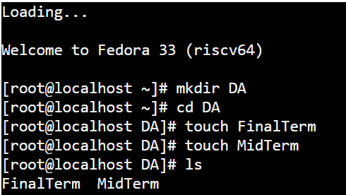

Creation of **Directory B** named as **DB** with two files **OSTheory** and. **OSLab.**

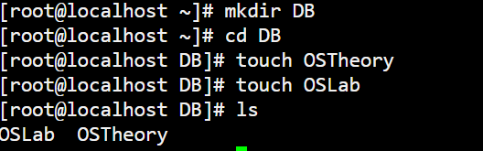

Moving MidTerm file from DA directory to DB directory and change the name of the moved file from MidTerm to TASK.

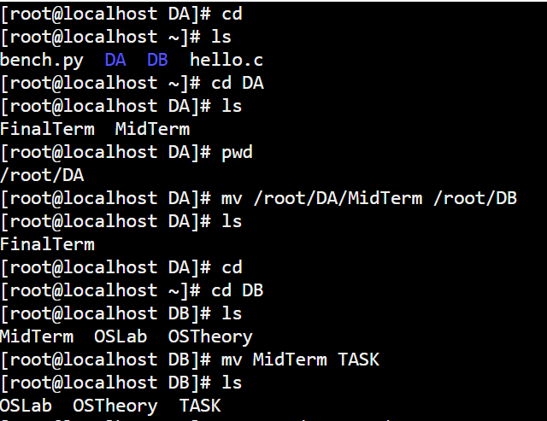

**Task 5:**

Creation of file with **nano** by name **MyFile.cpp**

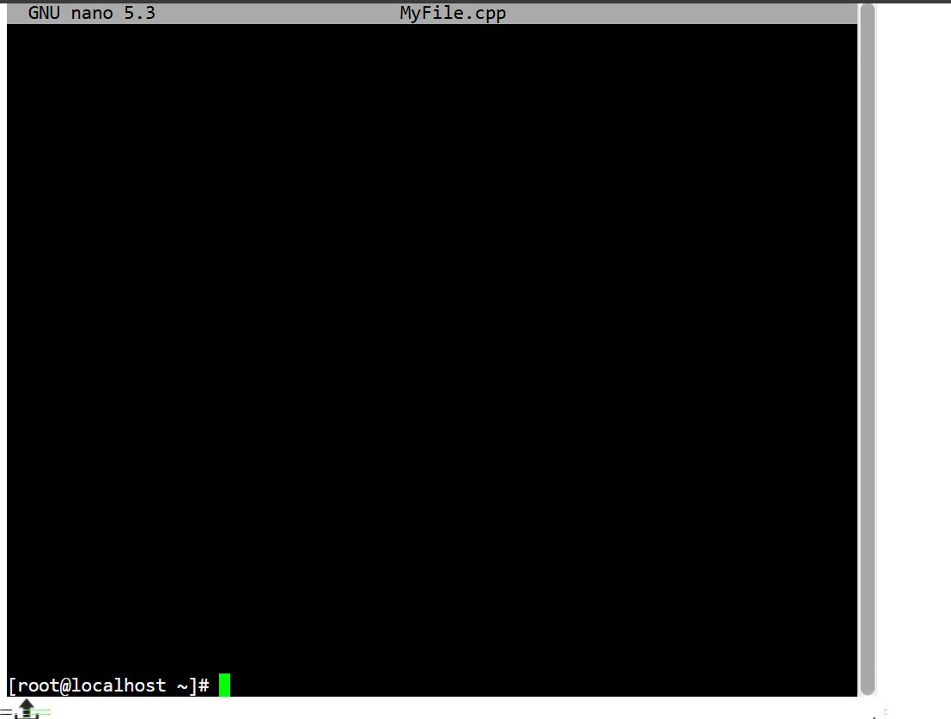

Writing the c++ code to print the circle.

